Revision History
Date | Version | Description | Author
10/11/2015 | 1.0 | Software Detailed Design (Version 1.0) | Caner Gülgeç -> Graphical User Interface Component  Arjen Kılıç -> Model Component  Cengizhan Özcan -> Controller Component  Erke Varol -> Controller Component  Şevval Tan -> Software Architecture Overview, Graphical User Interface Component  Introduction, COTS Identification –> Everyone participated.
18/11/2015 | 2.0 | Software Detailed Design (Version 2.0) | Caner Gülgeç -> Graphical User Interface Component  Arjen Kılıç -> Model Component  Cengizhan Özcan -> Controller Component  Erke Varol -> Controller Component  Şevval Tan -> Software Architecture Overview, Graphical User Interface Component  Introduction, COTS Identification –> Everyone participated.

TABLE OF CONTENTS
Revision History 1
1 Introduction 3
1.1 References 3
1.1.1 Project References 3
2 Software Architecture overview 3
3 Software design description 3
3.1 Graphical User Interface 3
3.1.1 Component interfaces 3
3.1.2 Component design description 3
3.1.3 Workflows and algorithms 3
3.1.4 Software requirements mapping 4
3.2 Controller 4
3.2.1 Component interfaces 4
3.2.2 Component design description 4
3.2.3 Workflows and algorithms 4
3.2.4 Software requirements mapping 5
3.3 Model 5
3.3.1 Component interfaces 5
3.3.2 Component design description 6
3.3.3 Software requirements mapping 6
4 COTS Identification 6

Introduction
This document describes the design of the EHITS software system.

References

Project References

# | Document Identifier | Document Title
[R1]  [R2]  [R3]  [R4]  [R5]  [R6] | 1  2  3  4  5  6 | SDP: Software Development Plan  SRS: Software Requirements Specifications  STP: Software Test Plan  Ozyegin LMS: https://lms.ozyegin.edu.tr  Ozyegin SIS: https://sis.ozyegin.edu.tr  Window Builder: https://eclipse.org/windowbuilder

Software Architecture overview
EHITS will be composed of three main components which are Graphical User Interface(GUI), Controller and Model. GUI and Model components will never be interacting with each other. GUI will only contain the View component of the software. Model will hold the data and Controller will be the bridge to keep the program working.
Both GUI and Model components will send requests to the Controller and they will also receive requests from the Controller, as shown in the graph.

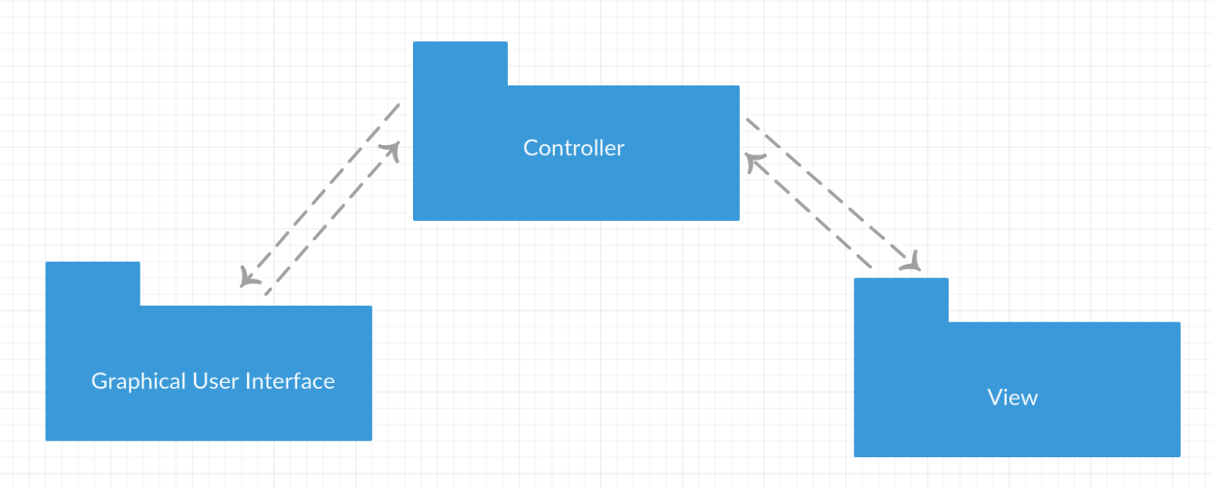

Software design description
· Graphical User Interface: This is the component which points the user actions to the controller. It allows user to display the data which was parsed and formatted by the project team members.
· Controller: The controller will be involved in an interaction with both GUI and Model components. It will be sending the data retrieved from the Model, to the GUI component.
· Model: It is the component that all data is stored and handled.

Graphical User Interface

Component interfaces
- The classes of this component will inherit from JFrame.
- CalendarFrame will be an abstract class and it will have 3 subclasses.
- Other components will not be able to reach the attributes of the classes in the GUI component, but they will be able to reach all the set() and get() methods of these classes.

3.1.2 Component design description
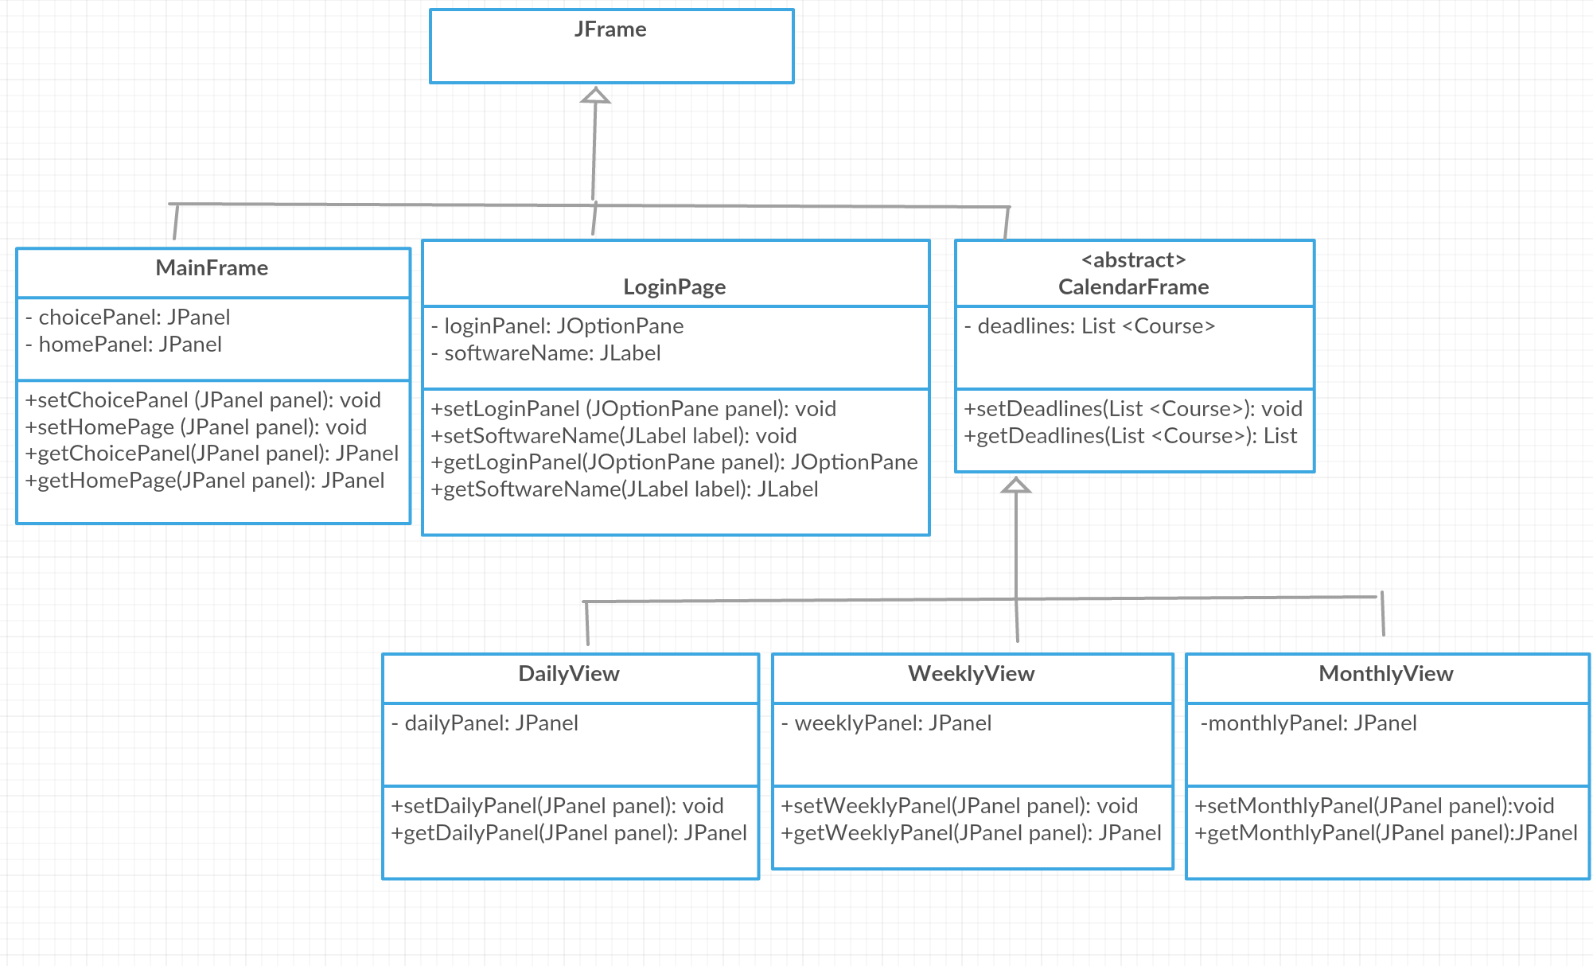

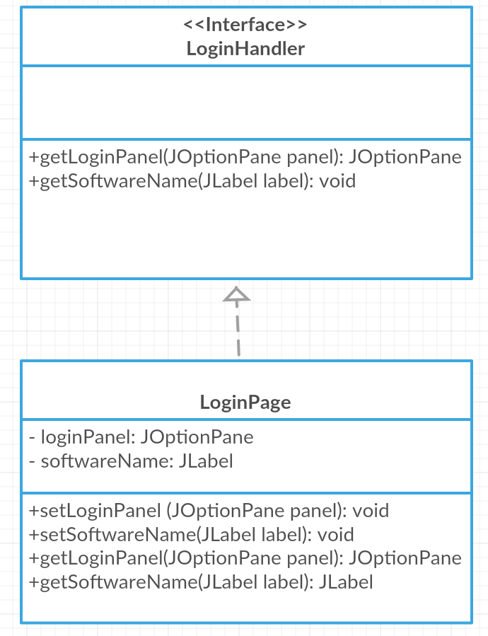

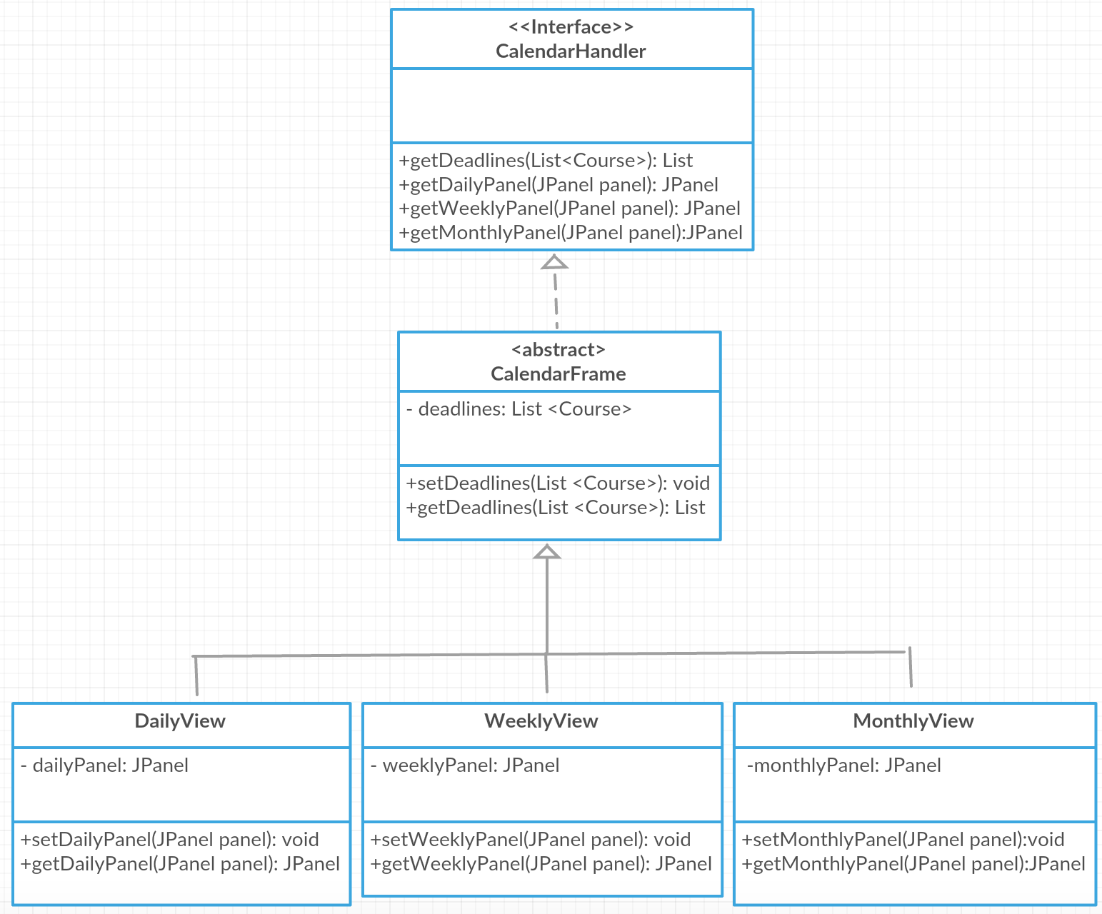

3.1.3 Workflows and algorithms
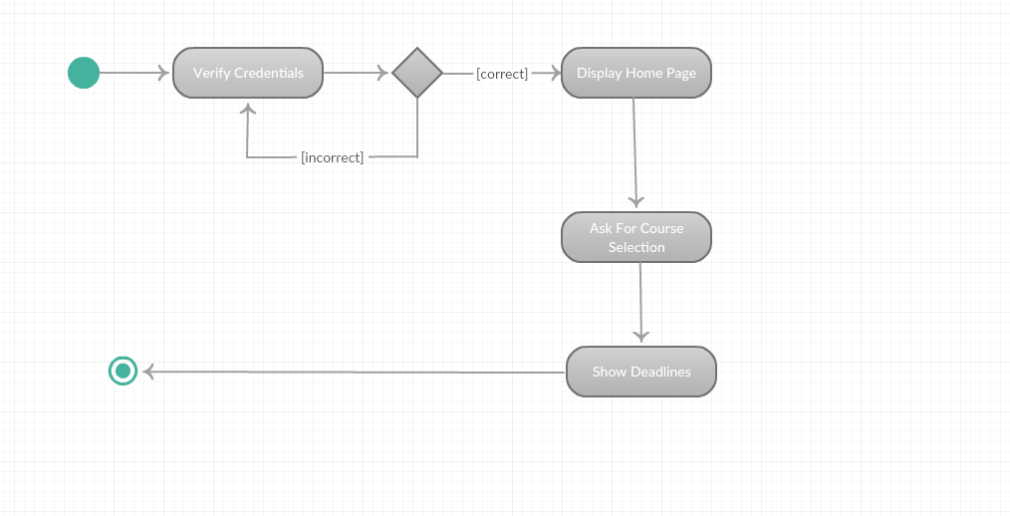

3.1.4 Software requirements mapping
Following is the list of SRS requirements handled by this component;
- SRS-EHITS-FR01
- SRS-EHITS-FR02

Controller
It sends the data retrieved from Graphical User Interface to Model component for analyzing and processing.

Component interfaces
- LoginHandler
  - Responsible to login the user email that is taken by user.
- CalendarHandler
  - Responsible for calendar and option panel will be displayed

Component design description
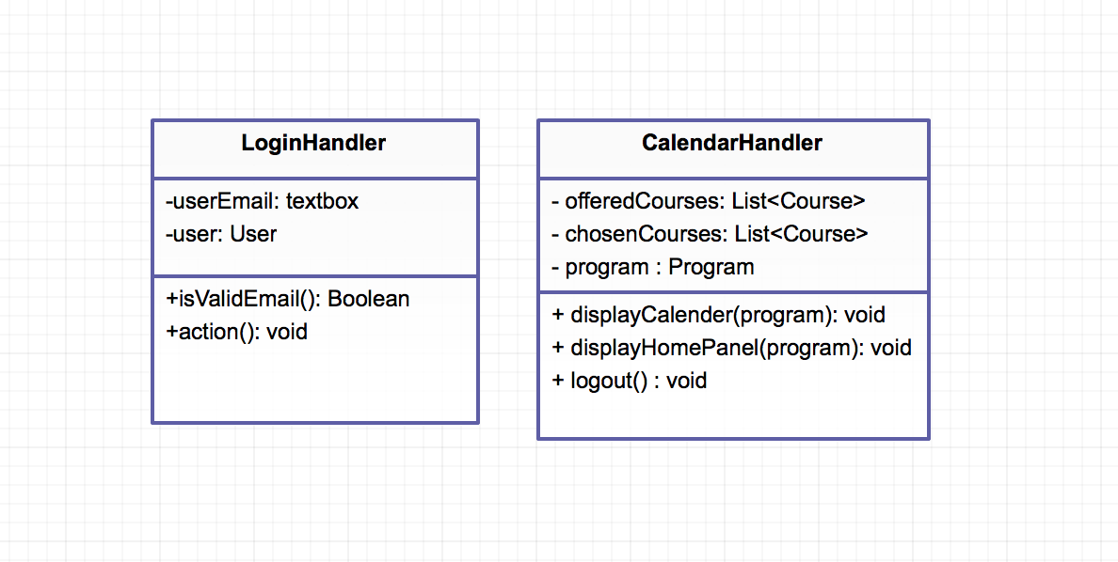

Workflows and algorithms

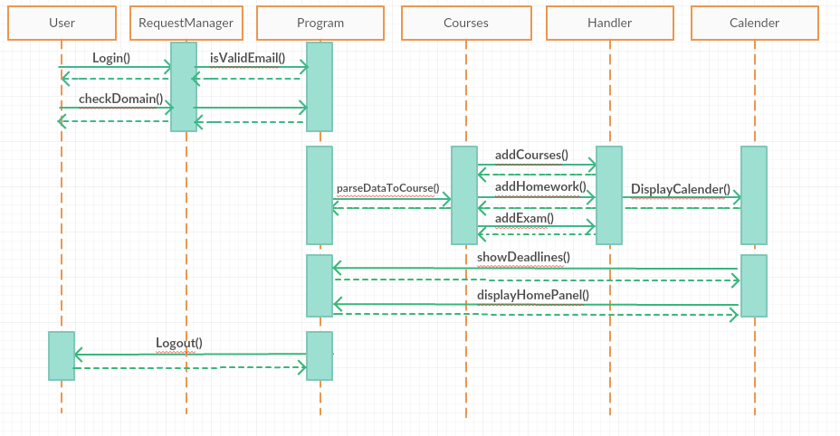

Software requirements mapping
SRS-EHITS-FR01
SRS-EHITS-FR02
SRS-EHITS-FR04

Model
All the data will be stored in this component. Also this data will be handled in that model component.

Component interfaces
- User
It stores all the data of the user that logged-in. E-mail, password, username and courses that user selected before, stored in this.
- Parser
It is responsible for get the courses data from the web server in JSON format and parse it to the objects.
- Course
It stores the course name, course id, semester, instructor and all the exam and homework deadline dates of a course.
- Program
It is responsible for overall processing of the program. All the courses will be stored here. User chooses the courses that he/she interested, then information of this courses will be shown to the user.
- Homework
It keeps deadline and given date of the homework
- Exam
It keeps exam date, exam place, exam duration.

Component design description
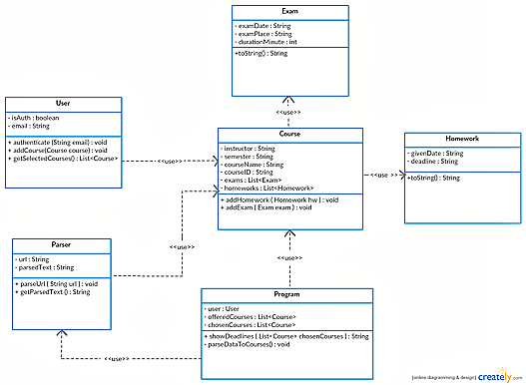

Software requirements mapping
● SRS-EHITS-FR01
● SRS-EHITS-FR02
● SRS-EHITS-FR03
● SRS-EHITS-FR04

COTS Identification
This section lists the external software components and libraries which will be used in the project.

COTS (commercial of the shelf) libraries used in EHITS are the following:
- java-json.jar, http://www.java2s.com/Code/Jar/j/Downloadjavajsonjar.htm

